Basic Structured Operations:
DataFrame consists of a series of records (like rows in a table), that are of type Row, and a number of columns (like columns in a spreadsheet)
Refering columns:
- By using col() or column() functions, we can refer the columns of a dataframe.
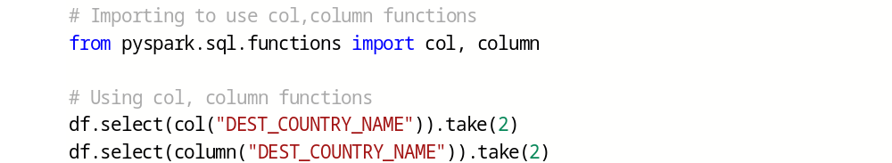
Expressions:
- An expression is a set of transformations on one or more values in a record in a DataFrame.
- Think of it like a function that takes as input one or more column names, resolves them, and then potentially applies more expressions to create a single value for each record in the dataframe.
- expr() function will be used to create expression.
Examples,
If just used a single column reference to expr() function, expr("somecol") is equivalent to col("somecol").
expr("somecol - 5") is equivalent to col("somecol") - 5

Getting DataFrame's columns:
- Use columns property on dataframe to see the columns,
DataFrame Transformations:
Following are several core operations,
- We can add rows or columns
- We can remove rows or columns
- We can transform a row into column (or vice versa)
- We can change order of rows based on the values in columns

Creating DataFrames:
- Creating dataframe from raw data sources (more we will see in later sessions)
- Creating dataframe with manual data
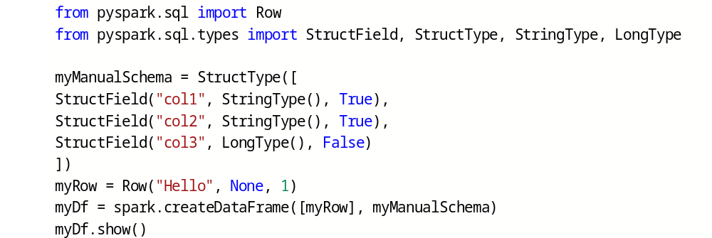

Select columns:
select:
- Can use select() function to manipulate the columns in your DataFrame like select statement in SQL query.

- Multiple columns can be passed like below,

- Can also specify expressions like below,
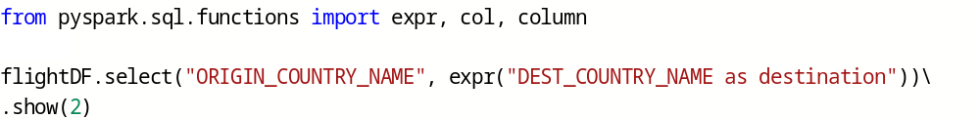
selectExpr:
- select() followed by a series of expr() is such a common pattern. selectExpr() function is the short-hand for doing this.

- We can add any valid non-aggregating SQL statement to selectExpr() function.
flightDF.selectExpr("*", "(DEST_COUNTRY_NAME == ORIGIN_COUNTRY_NAME) as WithInCountry").show(2)

- Can also specify aggregations over the entire DataFrame by taking advantage of the functions that we have

Converting to Spark types:
- lit() function translates the value from a given programming language to one that Spark understands.
Syntax:
lit(<Value>)
Example:

Adding Columns:
- withColumn() function adds a new column to existing dataframe.
Syntax:
withColumn(<ColumnName>, <Expression>)
Example:
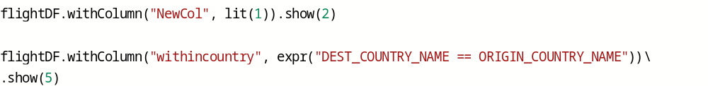

Renaming Columns:
- withColumnRenamed() function renames the column
Syntax:
withColumnRenamed(<ExistingName>, <NewName>)
Example:

Removing Columns:
- drop() function drops the column from the dataframe.
Syntax:
drop(<ColName>)
Example:
Changing column's datatype:
- cast() function will change the datatype of a column.
Syntax:
cast(<datatype>)
Example:

Filtering Rows:
- where() or filter() functions will be used to filter the data.
Syntax:
where(<FilterCondition>)
filter(<FilterCondition>)
Example:

Putting multiple expressions,
Example:

Sorting rows:
- sort() or orderBy() functions will be used to sort the rows. Both these functions works exactly same.
Syntax:
sort(<column>)
orderBy(<column>)
Example:
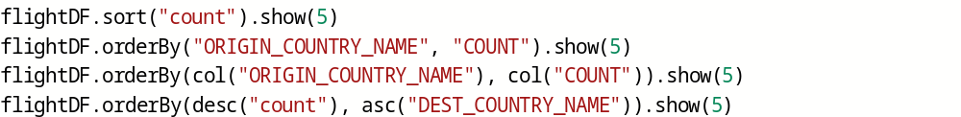

Getting unique rows:
- distinct() function gives the unique rows from dataframe.
Syntax:
distinct()
Example:

Splitting data randomly:
- randomSplit() function splits the data based on given weights.
Syntax:
randomSplit([<weight1>, <weight2>, ....], <seed>)
Example:
Here seed is useful to get the same random numbers different times.
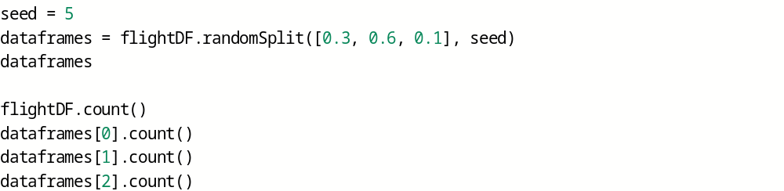

Getting sample data:
- sample() function gives the sample data from a dataframe.
Syntax:
sample(<withreplacement>, <fraction>, <seed>)
Example:
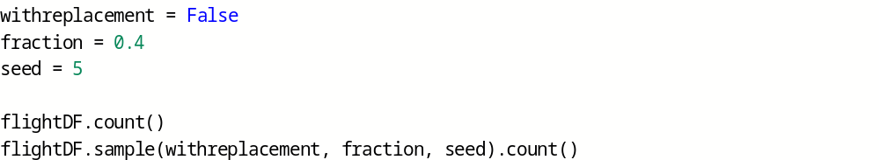

Limiting rows:
- limit() function limits the number of rows.
Syntax:
limit(<rowcount>)
Example:

Concatenating and Appending rows:
- union() function appends two dataframes data.
Syntax:
union(<otherdataframe>)
Example:
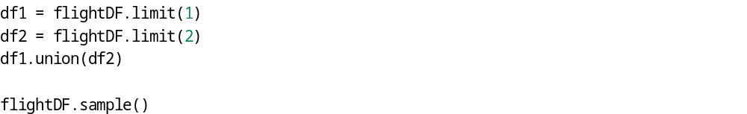

Repartition and Coalesce:
- repartition() and coalesce() functions are useful to control the partitioning.
repartition() -- Use if future number of partitions are greater than current number of partitions.
coalesce() -- Use to decrease the number of partitions.
Syntax:
repartition(<NumberOfPartitions>)
Example:

- If you know that you’re going to be filtering by a certain column often, it can be worth repartitioning based on that column:
Syntax:
repartition(<ColName>)
Example:
Collecting rows to Driver:
- collect() gets all data from the entire DataFrame, take() selects the first N rows, and show() prints out a number of rows nicely.
Example:

